|  |  |
| --- | --- |
| **Project Name** | Employee Tracking System |
| **Objective** | It is a system where employees come to our website and to show case their projects and review of their performance. The admin provides  task to the employees and manages tasks to Employees.  In this system, we also provide performance tracking of each  employee |
| **Platform** | Web-app |
| **Front End** | Html, Css, Bootstrap, Servlets, JSP |
| **Back End** | MySQL Database |

**FUNCTIONAL SPECIFICATIONS:**

**User Specification:**

Admin : He can add employees, manage employees and know the performance of each and every employee and also view feedback and enquiry.

User : He can view his tasks, performance report, and also give feedback.

**HARDWARE REQUIREMENT**

**Client side:**

|  |  |
| --- | --- |
| **RAM** | 2-4 GB |
| **Hard disk** | 10 GB |
| **Processor** | 2.0 GHz |

**Server Side:**

|  |  |
| --- | --- |
| **RAM** | 2-4 GB |
| **Hard disk** | 20 GB |
| **Processor** | 2.0 GHz |

**SOFTWARE REQUIREMENT**

**Client side:**

|  |  |
| --- | --- |
| **Web Browser Google, Mozilla Firefox etc.** |  |

**Server side:**

|  |  |
| --- | --- |
| **Web Server** | Tomcat server |
| **Database Server** | MySql |
| **Other Softwares** | Eclipse, Mysql-Workbench , Java |

**E-R DIAGRAM**

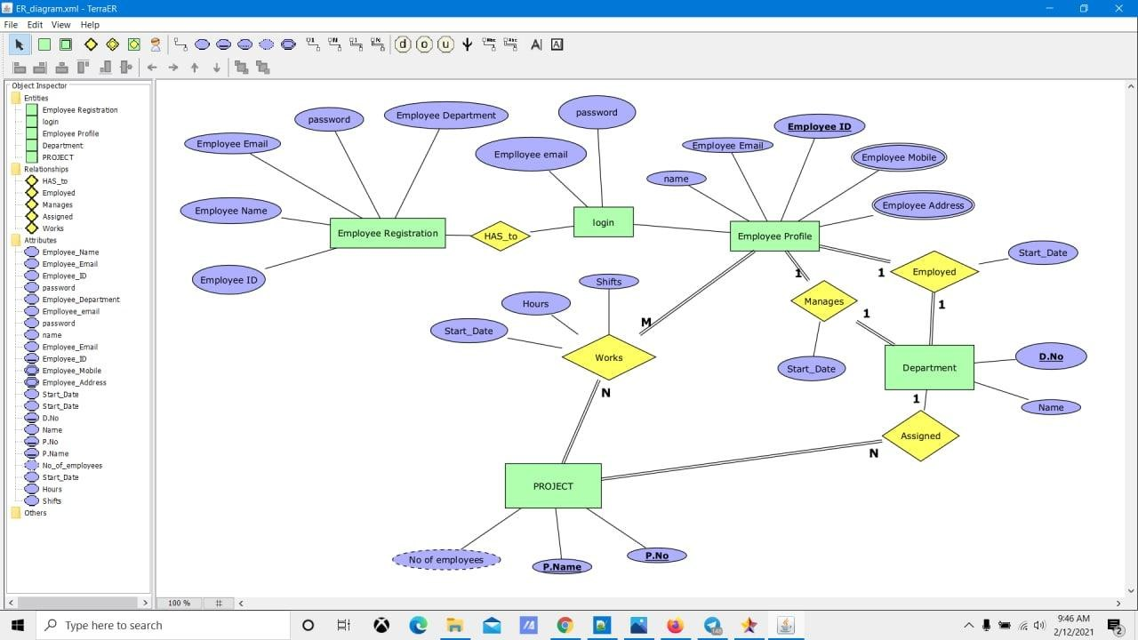

***E-R Diagram.***

**UML DIAGRAMS**

* **Use Case Diagram**

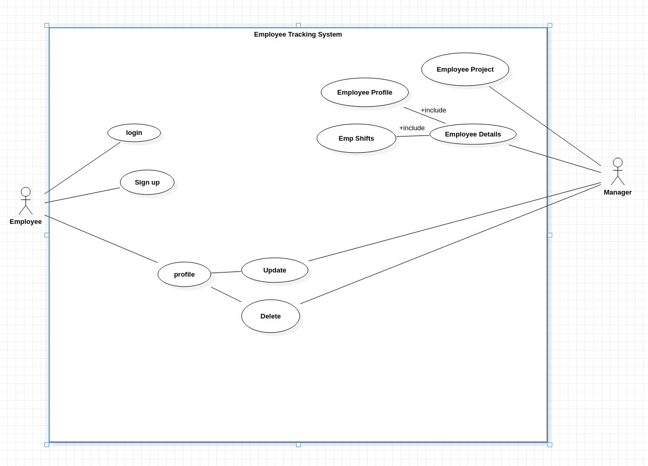

**Class Diagram**

* 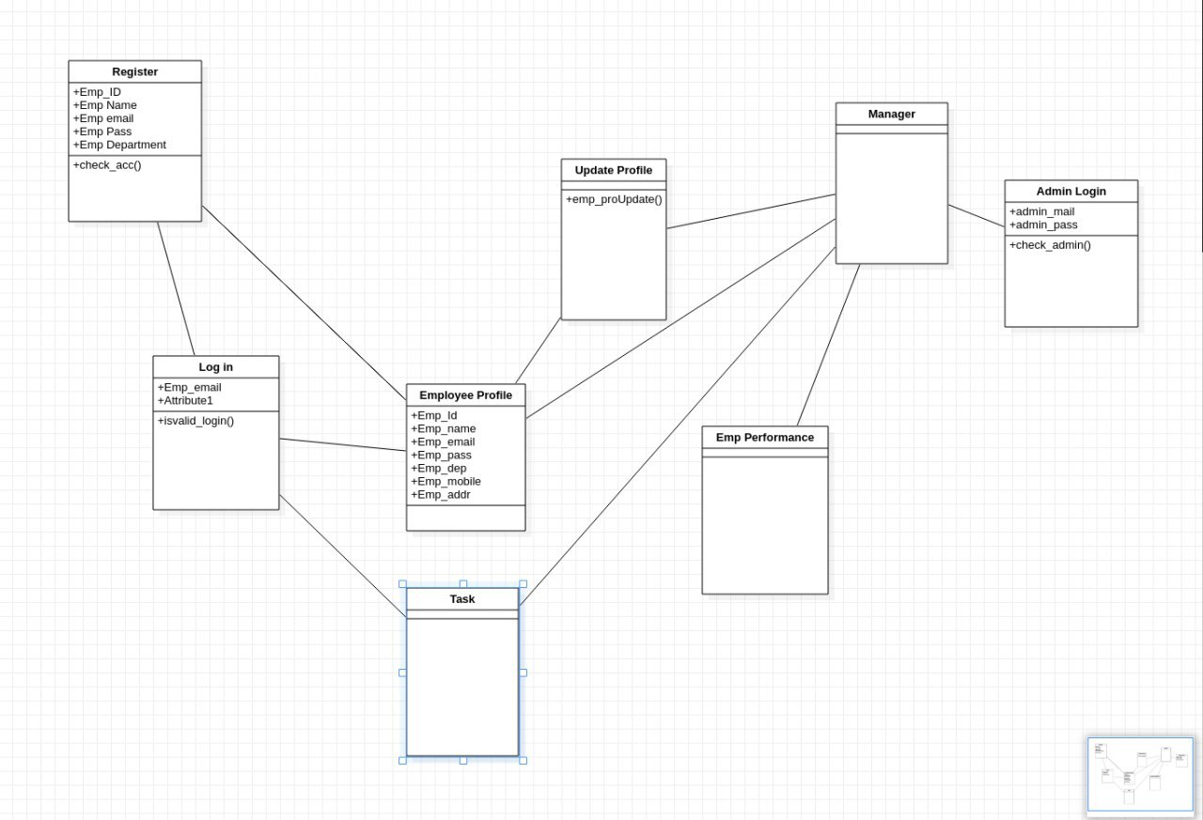
* When a new employee visits the website he can choose either to login or signup.
* If he choose to create a new account he will be asked to enter his details.
* If email or id already exists then he will be asked to use other email/id
* Else account will be created and he will be send to login page
* After logging in he can check his profile , edit his details , check his project details etc
* Let’s say the employee tries to open home page in one-more tab so then in-place of Login he will be getting his login details suggesting that he has already logged-in.
* And the tabs are also integrated using concept of Session-Tracking (HttpSession)

Admin :

View the list of Employees

Can access individual account details

Can mutate any account details

Can delete any account

Can assign task/project to employees

Can give a feedback to an employee based on his performance.

